**Methods**

*Study Area*

The research team focused its efforts on 18 counties, 13 in North Dakota, and 5 in South Dakota. A majority of these counties contained or were adjacent to the four National Grasslands that make up the Dakota Prairie Grasslands which are managed by the US Forest Service.

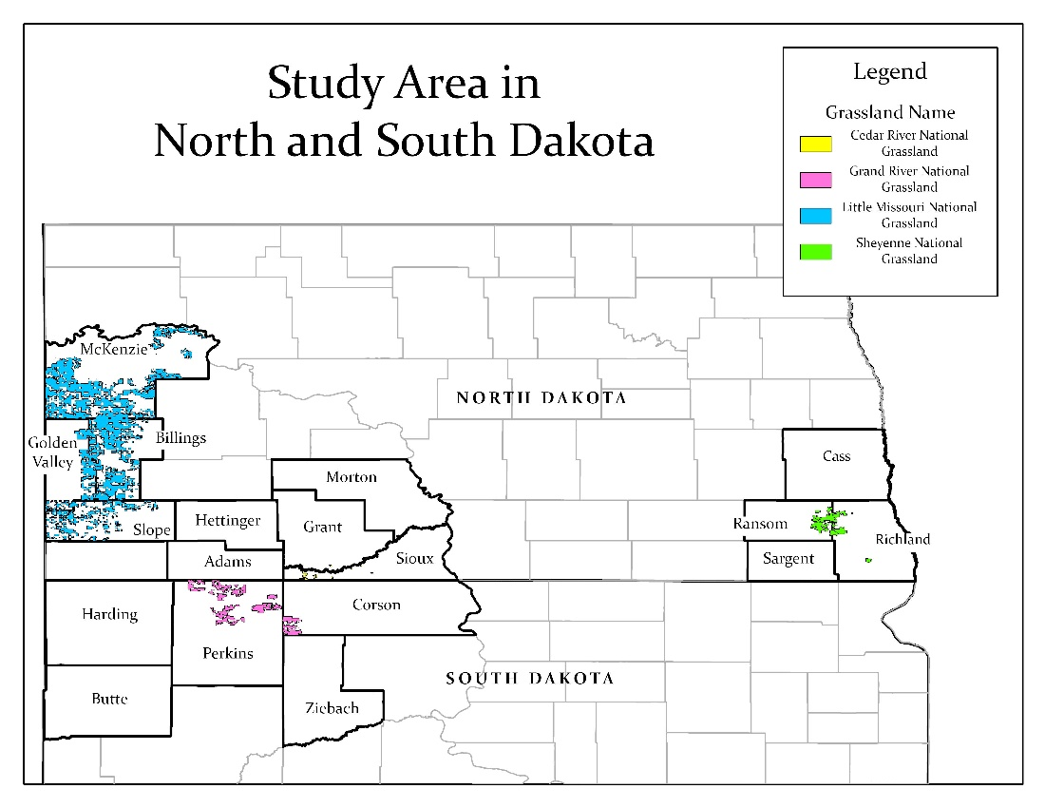

Fig X. This map shows the targeted study area. The 18 counties of interest are outlined in black and are labeled.

*Phase 1: Exploratory Phase*

*How I found people*

The sample of natural resource managers were identified and contacted using information on agency webpages. Researchers were further directed to additional natural resource managers by the initially contacted managers and agents. While the focus was on managers in the 18 counties (13 in North Dakota and 5 in South Dakota, Fig. X), some were regional or state level officials that operated across more than one county.

The research team initially reached out to Grazing Associations that use the National Grasslands in North Dakota and Northwestern South Dakota. They provided the research’s team contact information to their members who reached out to researchers at their own interest. From those initial contacts we conducted snowball sampling (asking participants to provide contact information for additional potential participants (Goodman 1961)).

As this process continued the control over location within the target 18 counties was less achievable, eventually the research team accepted a general delineation of being on the east or west side of the study area for grouping within the study.

*What I did*

The research team conducted semi-structured interviews with private landowners and natural resource managers across North Dakota and Northwestern South Dakota. These interviews were conducted using telephones or video calling at the participant’s interest. These interviews sought to understand general attitudes and opinions regarding prescribed fire use in the Northern Great Plains.

*What I did with the data*

The audio of these interviews were recorded using the Microsoft Windows voice recorder program then transcribed in a typed document. These transcripts were imported to R Studio and then coded using RQDA software (Huang 2016). These codes were used to identify major themes within the interviews.

*Phase 2: Confirmatory Phase*

*How I found people*

The survey was sent to producers in the counties of interest around the DPG. Participant information was primarily identified through a FOIA request. Counties where potential respondent numbers were small had additional information provided by FSA offices. Equal numbers of potential respondents were randomly selected for each of the 18 counties.

*What I did*

The second stage of our research was mailed surveys. We used a multi-stage mailing protocol (Dillman 2011) which included a pre-survey notice, the survey with cover letter and return envelope, a thank you/ final reminder postcard. Additionally, a non-response survey was sent to a portion of the non-responders.

The survey aimed to gather input from respondents who have cattle on both public and private land. This survey expanded upon the interviews and further investigated the perceptions and attitudes of producers towards prescribed fire. In addition to using results from the first phase of the research design, researchers also referenced survey instruments made available online from previous studies on the topic to guide instrument design.

To use structural equation modeling with the TPB, a large portion of the prescribed fire questions were intentionally designed to fit the flow of TPB. The structure of these questions were guided by the questionnaire development guide written by Ajzen (2006).

*What I did with the data*

The form for the survey was developed using the SDAPS program (Cite). SDAPS allowed researchers to scan completed surveys to collect a majority of the data therein. Short answer question responses were hand entered. This scanning process returned results in a spreadsheet that was analyzed using various applications in R.

Dillman, D. A. (2011). *Mail and Internet surveys: The tailored design method--2007 Update with new Internet, visual, and mixed-mode guide*. John Wiley & Sons.